Hi Aleks and Anna, here are the instructions/details for the other Ronson pages -

**This project is heavily based on the original polish website** [**http://ronson.pl/en/**](http://ronson.pl/en/)

**Please look at it while working as it can save you some time.**

**General**

* Mobile versions for all pages will be done next week.
* Here is a translation of the navigation, so you know to which page it leads –

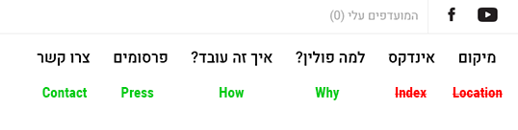

* Pages in green are included in this zip. Pages in red aren’t ready yet

**"Why" page**

No special instructions.

**“How”**

The 2 buttons on top will lead to other pages, please use placeholder links.

**“Press” page**

This page will feature different articles about the company. It’s a very basic “blog” system, also attached is an example PSD of an “article”.

The ideal system would be easy to update with new articles without alecs’ help.

It should have a picture slider on top and basic text below.

**“Contact” page**

Form on the right, you know the drill.

From top to bottom – name, phone, email, general comments

Thanks and good luck!